PCB Setup
After installation of PCB, setup may be required
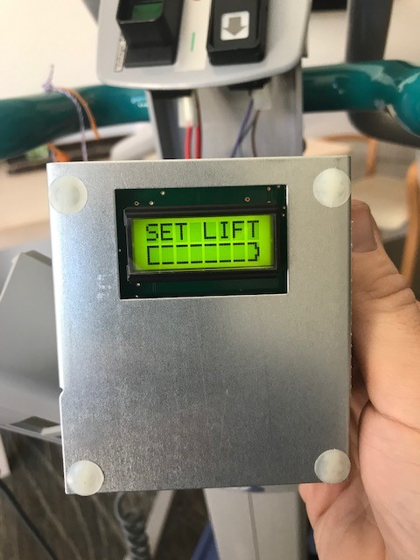
Turn lifter off
Hold up+down on hand control
Turn lifter on while holding
You should see this screen:
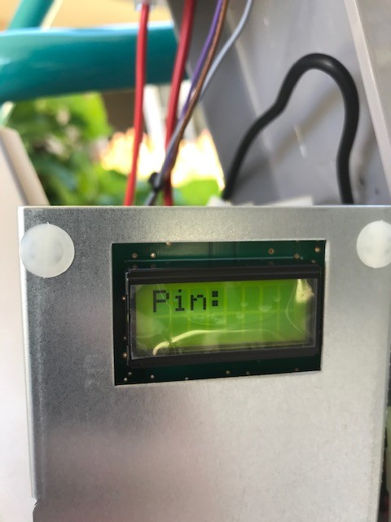
On the hand control press Up, Up, Down. Then press up+down together again to enter the Pin and reach the service menu.
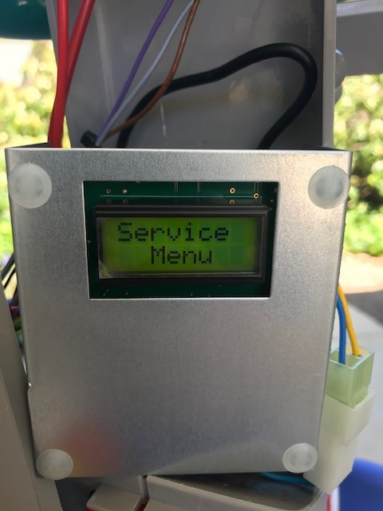
Use up/down to scroll through until you reach Type. Then use the leg actuator buttons to select Sara 3000 (there are other lifters to choose from so I think this will work when replacing control boards on any Arjo lifter).
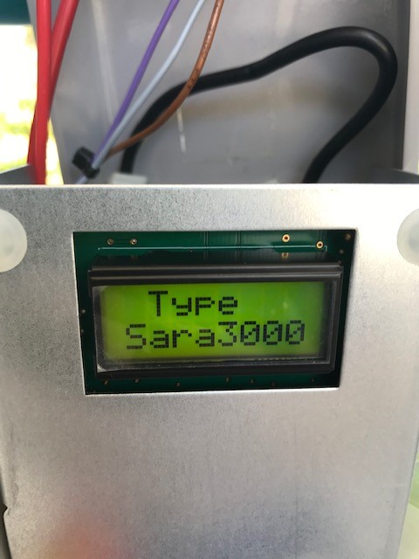
Once selected, turn lifter off and on again and it should work as normal.

